***Data Visualization Associate powered by Excelerate platform***

**Objective**

The primary objective of this project is to **analyze and integrate multiple datasets**—including user data and marketing data—from the **Excelerate learning platform**, perform an **in-depth data quality assessment**, and develop a **fully functional dashboard** using **PostgreSQL** for data processing and **Looker Studio** for visualization.

## ****Team Members and Roles****

### *****Team Lead*****

**Abigail Sunday Udo**  
  
➤ Represents the team to the sponsor on email and calls  
➤ Minimizes communication errors and leads team coordination

### *****Project Manager*****

**Siddharth Ramgundam**  
➤ Provides team guidance and draws insights from members  
➤ Keeps project execution on track

* ***Project Scribe***

**Adithya P K**  
➤ Records meeting minutes and shares notes and assignments  
➤ Assists Team Lead in drafting emails and sponsor communication

### ****Project Lead****

**Adithya Thirumala Reddy Vajrala**  
➤ Holds the team accountable for deadlines  
➤ Ensures all project deliverables are completed on time

* **Data Strategist**

**Abhay Rathore**  
➤ Conducts data analysis and strategy planning  
➤ Collaborates with the team on analytical execution

## ***Data Quality Exploratory Data Analysis (EDA)***

### Dataset Overview

* **Learner Data** – User profiles, education background, and enrollment status
* **Cohort Data** – Details of cohort-based learning programs
* **Marketing Campaigns** – Campaign performance and spending metrics
* **Tracking & Content Data** – Learner interactions and engagement
* **User Demographics** – Gender, location, birthdate, and other attributes

### Key Data Quality Issues Identified

### General Data Quality Observations

* Undocumented status codes present in learner records
* Duplicate entries based on learner ID and application date
* Learners assigned to multiple cohorts simultaneously
* Inconsistent NULL handling: both blank and literal "NULL" values
* Malformed data rows and inconsistent or corrupted ID formats

#### Inconsistencies & Duplicates

* Repeated campaign names (e.g., **"Copy 3"**, **"Copy 4"**) complicate performance tracking
* Demographic gaps: missing gender, birthdates, and postal codes
* Tracking data fields contain irregular naming and missing question values

#### Outliers & Anomalies

* Cohorts with **unrealistically large sizes** or durations of **0 days**
* Campaigns with **high spending but minimal engagement results**
* Erratic **cost-per-result** values across campaigns
* **Epoch-based timestamps** requiring human-readable conversion

### Key Insights

* **Improve Data Governance:** Apply rules to check data quality, remove duplicates, and use consistent naming.
* **Optimize Processes:** Set clear checks for data, manage marketing campaigns better, and fix import errors.
* **Enhance Data Quality:** Clean and standardize demographic data and other fields for

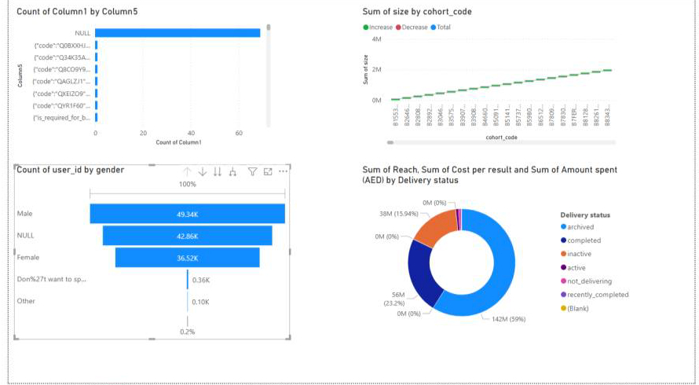

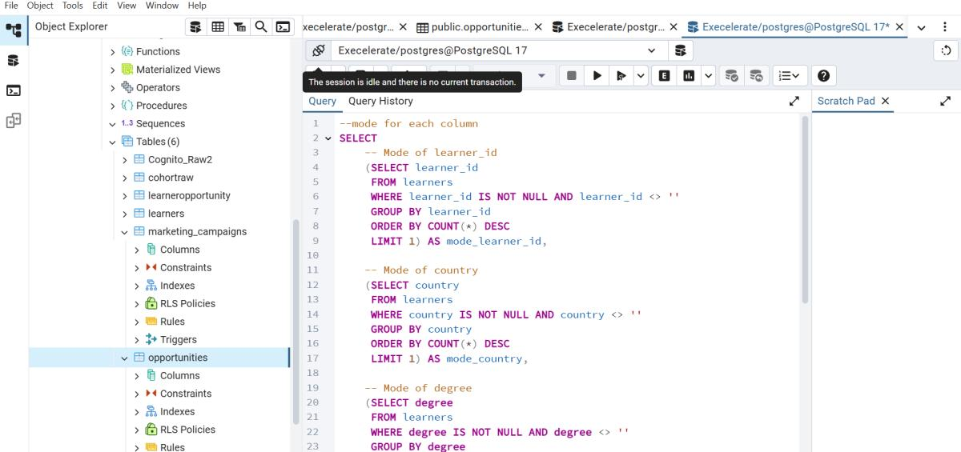

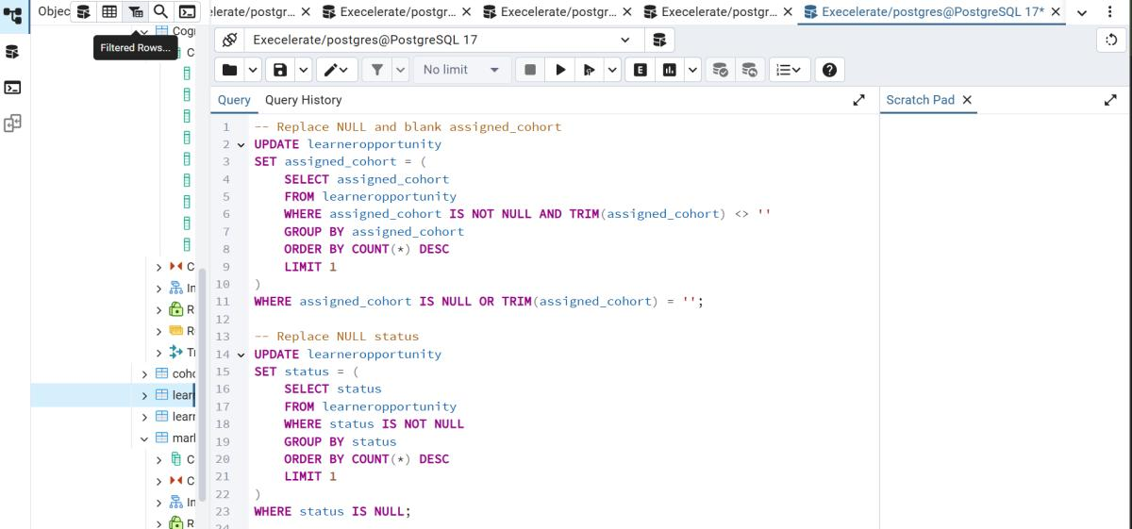

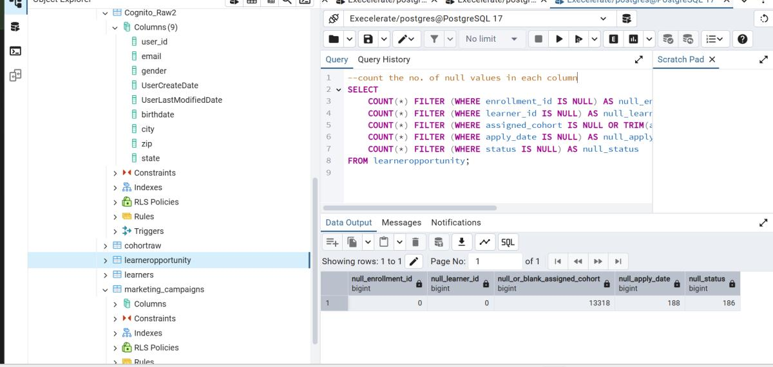

## Exploratory & Post-ETL Data Quality Assessment Report

### Exploratory Data Assessment (Pre-ETL):

#### ✅ Dataset Overview & Purpose

| **Dataset Name** | **Purpose Description** |
| --- | --- |
| Learner_Raw | Learner demographics and academic background |
| Opportunity_Raw | Learning/growth opportunity details |
| CohortRaw | Cohort schedules and details |
| ad_campaign_data | Ad campaign performance metrics |
| LearnerOpportunity_Raw | Mapping of learners to opportunities and cohorts |
| staging_users | User registration and profile info |

#### Dataset Relationships

Learner_Raw.learner_id ↔ LearnerOpportunity_Raw.learner_id

LearnerOpportunity_Raw.assigned_cohort ↔ CohortRaw.cohort_id

staging_users.email ↔ Learner_Raw.email

### **Pre-ETL Data Issues Identified:**

#### Missing Values

* Text-based "null" in degree, institution, major
* Blank or invalid gender, birthdate, state, zip
* Missing assigned_cohort and apply_date

#### Duplicate Records

* Duplicate learner_id
* Duplicate (enrollment_id, learner_id) combinations
* Duplicate user_id or email in staging_users

#### Inconsistent Formats

* Gender: 'male', 'Male', 'M'
* Country names: inconsistent casing
* Campaign data: inconsistent delivery_status, result_type

#### Orphan Records

* assigned_cohort not found in CohortRaw
* learner_id missing from Learner_Raw
* email in staging_users not matched in Learner_Raw

### ETL Transformation Plan:

Convert "null", "none", and blanks to NULL

Normalize casing (e.g., gender, country)

Remove duplicates using ROW_NUMBER() or DISTINCT

Enforce foreign key validation via joins

Correct data types (dates, numeric, categories)

### ✅ Post-ETL Validation:

| **Check Type** | **Purpose** | **Result** |
| --- | --- | --- |
| Record Count Validation | Ensure source and master table match | ✅ Match confirmed |
| Duplicate Checks | Eliminate enrollment_id, learner_id dupes | ✅ No duplicates found |
| Missing Data Review | Confirm clean and proper NULL usage | ✅ Cleaned successfully |
| Foreign Key Integrity | Validate cross-table references | ✅ All keys matched |
| Data Type Verification | Ensure correct formats for all fields | ✅ Verified |

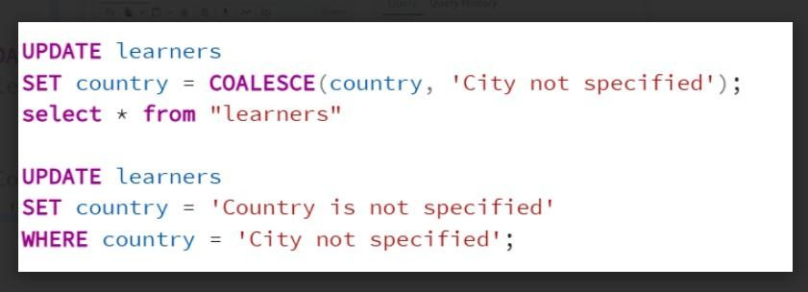

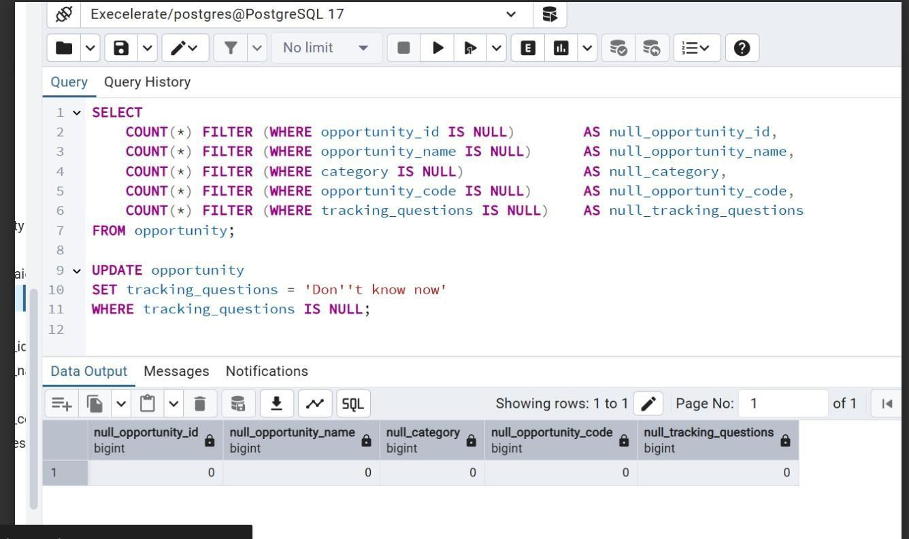

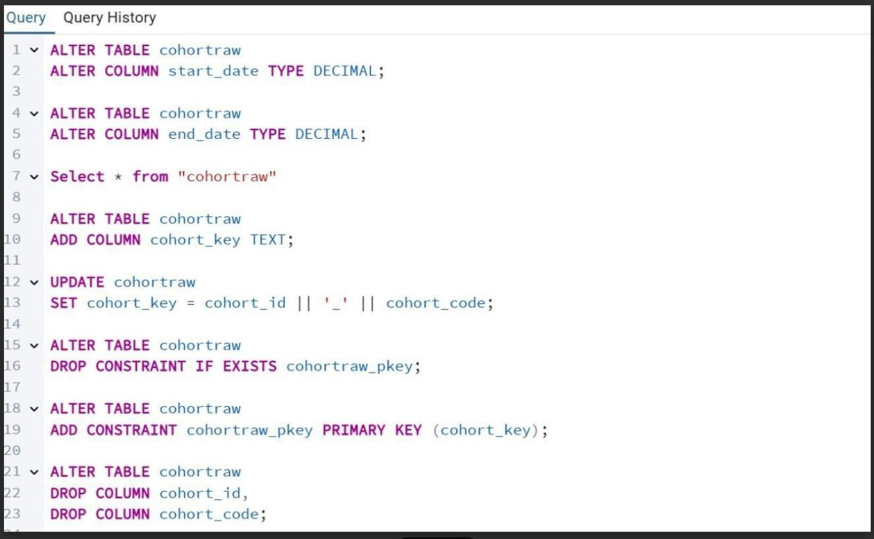

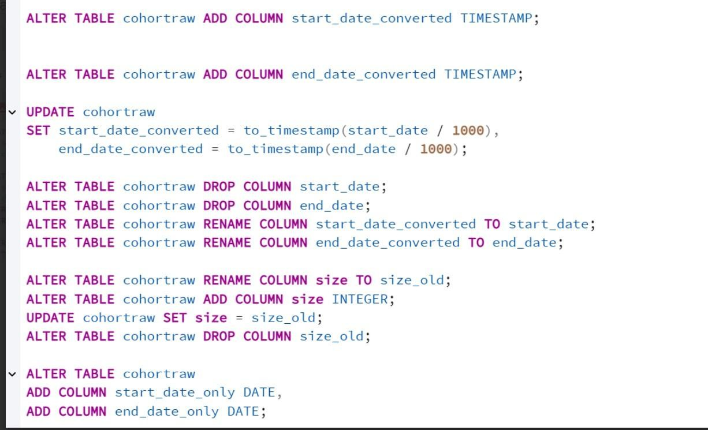

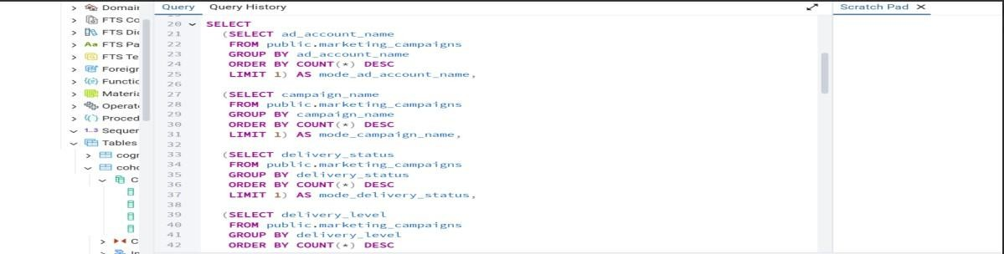

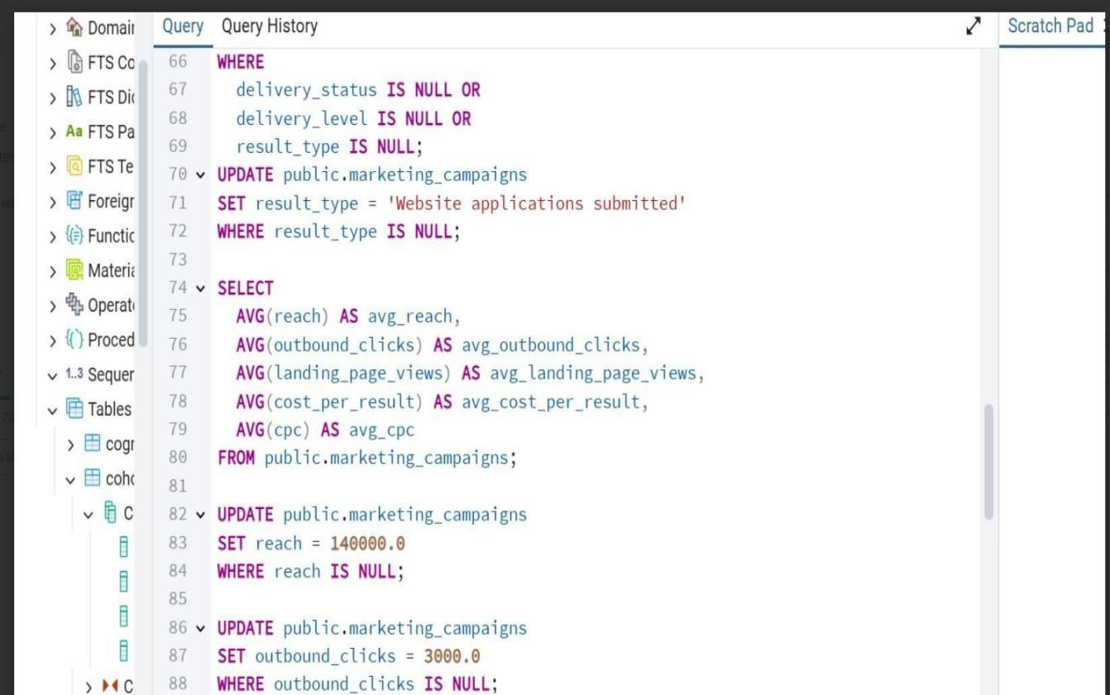

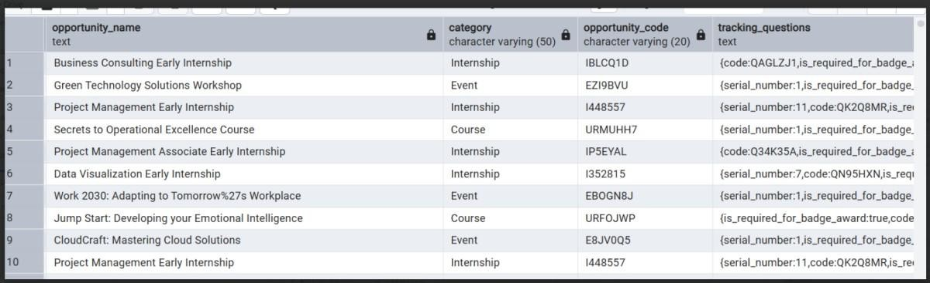

**Data Mapping & Dashboard Wireframe**

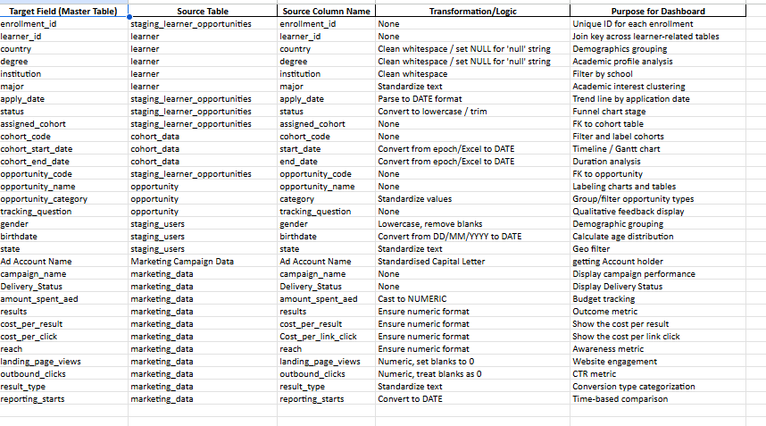

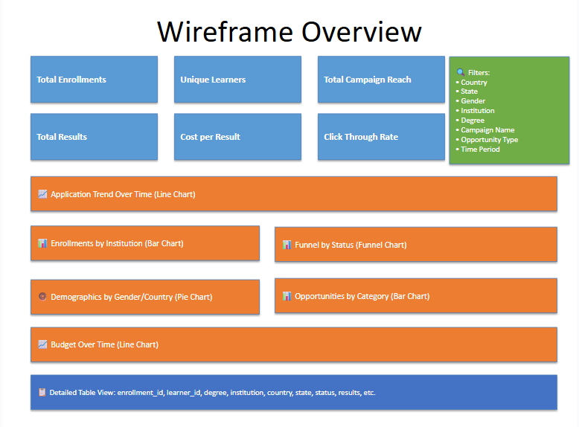

***Dashboard Overview***

